# VISION AND MISSION OF THE INSTITUTE

**Vision**

To admit and groom students from rural background and be a truly rural technical institution, benefiting society and nation as a whole institute.

# Mission

The mission of the institution is to create, deliver and refine knowledge. Being a rural technical institute, we aim to:

* Enhance our position to one of the best technical institutions and to measure our performance against the highest defined standards.
* Provide highest quality learning environment to our students for their greater well-beingso as to equip them with highest technical and professional ethics.
* Produce engineering graduates fully equipped to meet the ever-growing needs of industry and society.

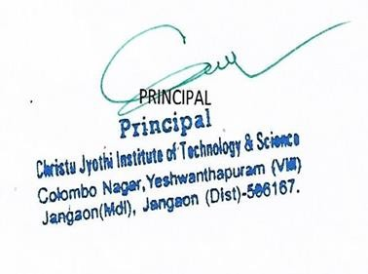

v

# DEPARTMENT VISION & MISSION

**Vision**

To be a center of eminence to mould young, fresh minds into challenging computer science professionals with ethical values.

# Mission

1. Enrich the knowledge and wisdom with repository of books and modernized laboratory aided by dedicated resources.
2. Organize training and activities on upcoming techniques, and inter-personal skills.
3. Develop the ability to provide sustainable solutions to real world situations with collaborations.

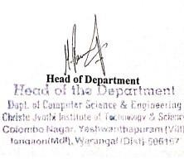

# PROGRAM EDUCATIONAL OBJECTIVES

**PEO1** Graduates of B.Tech (CSE) are able to formulate, analyse and solve hardware and software problems within the constraints and pursue research.

**PEO2** Demonstrate knowledge on core areas of Computer Science and related engineering to comprehend engineering trade-offsto create novel products.

**PEO3** Show the awareness of life-long learning needed for a successful professional career and exhibit ethical values, excellence, leadership and social responsibility.



# Screenshot 2022-11-26 104016.jpgPROGRAM OUTCOMES

**PROGRAM SPECIFIC OUTCOMES**

**PS01** Proficiency skill: Understand, analyze and develop computer programs in the areas related to algorithms, system software, multimedia, web design, big data analytics and networking for efficient design of computer-based systems of varying complexity.

**PS02** Problem-Solving Skills: Apply standard practices and strategies in software project development using open-ended programming environments to deliver a quality product for business success.

**PS03** Successful Career and Entrepreneurship: Employ modern computer languages, environments and platforms in creating innovative career paths to be an entrepreneur and a zest for higher studies.

